|  |  |
| --- | --- |
| A picture of a winding road and trees  Term Paper | Abstract  In this research the literature on price formation and negotiation is reviewed, as is the impact of market organization on price discovery and welfare. Theoretical, empirical and experimental approaches are considered from the same point of view. We present evidence related to frictions such as unwanted selection, inventory costs and market strength, as well as evidence of the impact on trading prices and transaction costs. We examine how market design features such as the level of transparency, the use of call auctions, the pricing grid, and the regulation of competition between liquidity or exchange providers can reduce friction. |

**UNIVERSITY OF ESSEX**

**DEPARTMENT OF ECONOMICS**

**MSC IN COMPUTATIONAL ECONOMICS, FINANCIAL MARKETS AND POLICY**

**TERM PAPER FOR EC912-7-** **Computational Market Microstructure for FinTech and the Digital Economy**

By

Murtaza Ahmed Butt

mb22447@essex.ac.uk

Suvervisor: Professor Sheri Markose

Table of Contents

Section 1: Introduction 2

Section 2: Overview On London Electronic Order Book 3

Section 3: High Frequency Algorithmic Trading 9

Section 4: Data and Methodologies 12

Section 5: Time Stamps Demand and Supply Curves for Price Trend Prediction 17

Demand and Supply Curves 20

Section 6: Price Impact Methodology 34

Section 7 Conclusions 40

References 42

Appendix 44

# Section 1: Introduction

Although started in the late 1980s, the transformation of European financial market structure accelerated in the 1990s in preparation for monetary union. It has been around 11 years since the London Stock Exchange (LSE) transitioned to a pure market structure (Sun, Y., and Ibikunle, G. 2016). These trade agreements have been criticized for their opacity and high transaction costs for small investors. In October 1997, in response to growing competition, the LSE launched Exchange Trading Services. With the introduction of SETS, the trading system for all FTSE 100 stocks will change from a price-driven market structure to Exchange Automated Quotations (SEAQ), an order-based market structure. This system extension allows market participants to compete with traders and Designated Market Makers (DMMs) by modifying order flow parameters.

This system update allows market participants to compete with traders and Designated Market Makers (DMMs) for order flow by setting desired bid and ask levels. With the advancement of information technology, the modern financial market has undergone rapid changes. Thanks to state-of-the-art technology, investors can now use high-frequency computerized trading platforms. Automated high-frequency trading (HFT) has proliferated over the past 20 years and now accounts for nearly half of all trading activity on global exchanges (Zook & Grote, 2017).

To promote competition and better prices, new trading rules were introduced and the market landscape changed. In order to provide a high level of standardized protection to market participants and financial instruments, new laws have been enacted in Europe, such as the Markets in Financial Instruments Directive (MiFID). The functioning of financial markets has recently been significantly impacted by technological advances and new market regulations. Financial markets have become so complex that computer algorithms now manage the majority of order execution. In addition, modern high-tech trading platforms such as dark pools are increasingly dominating financial markets. Dark pools are exclusive markets for trading securities that are inaccessible to public investors. Dark pools are designed to allow institutional investors to place large trades who do not want to disrupt the market with large orders and receive unfavourable trade prices. Since the introduction of SETS in 1997, the LSE has grown from a purely price-oriented exchange to a hybrid exchange combining a price-oriented segment and a limited order book.

This hardware upgrade gives users access to a centralized electronic order book where they can compete for order flow. With sub-second latency, SETS can execute millions of trades per day, increasing high-frequency trading activity on the UK stock market. Some ten years after the launch of SETS, Markets in Financial Instruments Directive (MiFID) continues to change the market environment by encouraging the creation of more trading venues, thereby increasing competition for order flow (Zook and Grote, 2022).

Despite these advantages, significant theoretical and practical hurdles remain in e-commerce and electronic financial markets. In order to successfully optimize the market and the planning of limit orders in an environment where electronic limit order systems are very fast and complex, professionals have invested heavily in computerized trading platforms.

# Section 2: Overview On London Electronic Order Book

LSE's international order book gives investors access to some of the world's fastest-growing markets via a single, centralized electronic order book. Limit orders' informational nature has been the focus of increasing market microstructure research. An order book is an electronic cluster of active limit orders for a specific financial instrument, such as a stock, and the Order Book Bundle provides a mechanism for viewing and acquiring data related to an order book. A proposal to purchase or sell a particular quantity of stock at a price that is superior to the limit is known as a limit order. The number of shares purchased or sold is referred to as size. It remains in the order book until the order is fully filled or the order size becomes zero due to the trade. (The R Journal)

Let us assume a simple order book (Table 1) that consist of five limit orders: sell 200 shares of Shell PLC at £81.00, sell 200 shares of Shell PLC at £81.12, buy 150 shares of Shell PLC at £80.81, buy 300 shares of Shell PLC at £80.50, and buy 200 shares of Shell PLC at £80.05.

Table 1

|  |  |  |  |
| --- | --- | --- | --- |
| **Bid** | | **Ask** | |
| **Price in £** | **Size/ Volume** | **Price in £** | **Size/Volume** |
| 80.81 | 150 | 81.00 | 200 |
| 80.50 | 300 | 81.12 | 200 |
| 80.05 | 200 | 81 | 80.9 |

Table 1 shows that buy and sell orders on the bid side, from highest (best price) to lowest and lowest (best price) to highest, respectively, indicate readiness for orders to buy or sell a stock that is listed in the trading book. The highest bid is £80.81, while the highest asking price is £81.00. The difference between the best-ask and best-bid prices, which also measures the market's efficiency, is £0.19. The median (£80.905) was determined by calculating the best bid and best ask's mean.

The order book can receive four different types of notifications from traders: add, cancel, cancel/replace and market orders. Traders can add limit orders to the order book. Trader can also cancel the purchase and remove it from the order book. Traders can use cancel/replace orders to reduce the size of their trades. This will cancel the original order and immediately replace it with a new order of the same price and size.

Each limit order has a distinct identifier to allow cancellation and cancellation/ replacement orders to identify the corresponding limit order. A market order is an order to buy or sell a certain number of shares right away at the best price. When a market order "hits" a limit order on the opposite side of the inside market, a trade begins.

Each order has a timestamp indicating when it was added to the order book. The temporal priority of an order is determined by a timestamp. For example, as shown in Table 1.1, Mr. A has placed an order to buy 150 shares at £80.75, along the side Mr. B has also placed an order to buy 200 shares at £80.75, subsequently a sell order has been place to sale 250 shares at £80.75, as per temporal priority, Mr. A will get 150 shares at £80.75 and Mr. B will get 100 remaining shares for the order at £80.75, After the execution, Mr. B would be left with an order to buy 100 shares at £80.75 as shown in the update order limit book (1.2).

Table1.1

|  |  |  |  |  |  |
| --- | --- | --- | --- | --- | --- |
| **Bid** | | | **Ask** | | |
| **Time** | **Price in £** | **Size/ Volume** | **Time** | **Price in £** | **Size/ Volume** |
| 09:15:12 | 80.75 | 150 | 09:16:11 | 80.75 | 250 |
| 09:15:18 | 80.75 | 200 | 09:10:13 | 82.00 | 150 |
| 09:18:47 | 80.50 | 100 |  |  |  |

Table 1.2

|  |  |  |  |  |  |
| --- | --- | --- | --- | --- | --- |
| **Bid** | | | **Ask** | | |
| **Time** | **Price in £** | **Size/ Volume** | **Time** | **Price in £** | **Size/ Volume** |
| 09:15:18 | 80.75 | 100 | 09:10:13 | 82.00 | 150 |
| 09:18:47 | 80.50 | 100 |  |  |  |

The order remains in the order book until it is fully executed. Transactions below the total amount of the order will result in partial fulfilment. According to Kolm and Maclin (2011), A conditional time-in-force order known as a “fill or kill” (FOK) orders an agent to complete a trade in full and quickly, or not to execute it at all. Active traders most often use this order form and it is usually a large amount of shares. An order to buy or sell shares which must be filled in full immediately in order to avoid cancellation of the entire order is known as a fill or cancel order (i.e. partial execution of the order is not permitted). (Investor.gov). Limit orders above the best bid and ask prices will match in order to fill the gap created by a market order at the best price above the volume. (InacioManjamaTerm Paper).

An iceberg order is an order to buy or sell a large number of financial securities that are broken down into smaller orders rather than submitted as one large order. This method of buying and selling stocks is known as the "iceberg method" because each small trade represents only a small fraction of the total order size. Traders who trade large amounts of financial stocks prefer iceberg orders. The sheer volume of transactions they have to make can now drastically change the price of the stock, as more buy and sell orders create more supply and demand pressure in the market (Segletes, Grote and Polesne, 2000).

Figure 1.0

For example, as illustrated in the figure 1.0, a single order to buy 50,000 shares of a stock could represent a large increase in demand for that stock. Therefore, the share price is likely to rise. Likewise, a sell order for 50,000 shares of a stock could drive down the price. Large traders use iceberg orders to complete a desired total amount of buy or sell in a series of relatively small trades. In doing so, they try to prevent the stock price from moving sharply in their favour and are able to execute all buys and sells at or near the expected price.

An order to buy or sell a security that has been submitted and cancelled before the exchange executes it is called a cancelled order. A limit order or stop loss order is a regular order that investors can cancel at any time as long as the order has not been executed. Logically, limit and stop orders can be easily cancelled as they may not execute for hours or even days depending on the price movement. It is extremely unlikely that a market order will be cancelled.

When liquidity is plentiful and markets are open during normal business hours, most market orders are filled almost immediately upon reaching the exchange. Because of this, it is almost impossible to cancel a market order before it is executed. Limit orders can usually be cancelled online through the broker's web platform, or if necessary, by calling the broker directly. A limit order is an order to buy below the bid price or to sell above the ask price.

Two related orders form an order covering the other (OCO), if one is executed, the other is cancelled immediately. This type of order can be used by traders for breakouts. For example, if a stock is trading between £20 and £40, a trader can set up an OCO where buy orders are just above the trading range and sell orders are just below the trading range. If the stock rises, the buy order will be executed and the sell order will be cancelled. On the other hand, if the price falls below the trading range, the sell order is executed and the buy order is cancelled. This method of ordering reduces your risk by ensuring that incorrect orders are automatically cancelled.

Berkowitz and others A volume-weighted average price (VWAP) market impact metric for a trading day was proposed by (1988) to figure out the best ways to analyze and extract the information contained in limit orders and use this information to design the best survey trades strategy. Malik and Markose (2012) developed a quantitative framework to measure the empirical liquidity shape change of supply and demand curves based on this metric and proposed volume-weighted nominal pricing (NVWAP). After that, Malik and Ng analyze the impact on the intraday market through the use of nonparametric kernel regression. The main takeaway from these studies is that the proposed method works well for getting information and predicting how prices will change in the future (Sarkar, Tiwari and Giri, 2022).

# Section 3: High Frequency Algorithmic Trading

The high-speed, high-volume trading that we now classify as HFT evolved with the passage of time, that has been around since the 1930s. To connect the Chicago data centre to New Jersey, 827 miles of cable had been built as of early 2009. Estimated cost is $300 million (Forbes). In order to minimize competition, the plan must be conducted in absolute secrecy. High frequency trading, also known as HFT, takes algorithmic trading to an entirely new level. High-frequency trading, as the name suggests, involves placing thousands of orders at breakneck speed. Computer algorithms, which are essentially a set of rules or instructions that direct a machine to perform specific tasks, are used in the practice of algorithmic trading, which involves trading large stocks or other financial assets. To minimize the impact on the price of a stock or asset, algorithmic trading divides trades based on predetermined criteria into smaller lot sizes.

The goal is to make a small profit on each trade, usually from differences in the price of the same stock or commodity in different markets. Because the arbitrage and market-making trades that form the backbone of high-frequency trading typically occur for short periods of time before price differences or mismatches disappear, high-frequency trading is the polar opposite of traditional long-term investing. Due to a combination of factors, high-frequency trading and algorithmic trading have emerged as significant components of financial markets. These include the complexity of financial instruments and commodities, the ever-increasing influence of technology on modern markets, and the unrelenting pursuit of reducing transaction costs and increasing efficiency in transaction execution (Hossain, Shahadat. 2022. "High-Frequency Trading (HFT) and Market Quality Research).

One of the greatest threats to the financial system is high-frequency algorithmic trading. The Technical Committee of the International Organization of Securities Commissions (IOSCO) published a report in July 2011 stating that because of the close connections between financial markets, algorithms operating in those markets are able to quickly transmit shocks from one market to another, including American financial markets. Markets. thereby making systemic risk worse. The flash crash in May 2010 serves as a good illustration of this danger. In what became known as the "Flash Crash," major US stock indices experienced a 5- to 6-percent decline on May 6, 2010, before soaring within minutes. At the time, a loss of nearly 1,000 points in a single day was the Dow Jones Industrial Average's largest point decline ever. The day before recovering the majority of their losses, many stocks and exchange-traded funds (ETFs), as noted in the IOSCO report, fell between 5% and 15%. As a result of some trades being made at ridiculous prices ranging from a penny to $100,000, over 20,000 trades in 300 stocks were 60 percent less than they were just a few seconds ago (Investopedia).

Importantly, because there is so much high-frequency algorithmic trading activity in the market today, many algorithms have the ability to dynamically outperform their competitors. Algorithms can react immediately to changes in the market. As a result, algorithms can dramatically increase inventory between bid and ask spread (you don't have to hold trading positions) or temporarily halt trades, reducing liquidity and increasing volatility. Market volatility is often caused by algorithmic high-frequency trading, which can have a short-term negative impact on investor confidence and a long-term positive impact on consumer confidence. Investors face a dilemma when markets suddenly plummet, wondering why such a drastic action was taken. Large traders (including high-frequency trading firms) will reduce their trading positions to reduce risk during media vacuums, which often occur during these times and continue to depress markets. As the market falls, more stops are triggered, and this negative feedback loop amplifies the downtrend. If that behaviour leads to a bear market, the erosion of wealth in the stock market and signs of a recession after a sharp market slide is hurting consumer confidence (Zhang, Li and Krishnan, 2020).

Misbehaving algorithms given how quickly most algorithmic HFT trades are executed, a faulty algorithm can cost millions of dollars in a very short time. As a market maker who lost $440 million in just 45 minutes on August 1, 2012, Knight Capital is a well-known example of the damage an algorithmic error can cause. Millions of errors were made by Knight's new trading algorithm, which bought 150 shares of a stock at a high "sell" price and immediately sold them back at a low "buy" price. Remember that market makers profit from trading by buying stocks from investors at the bid price and selling them back at the ask price. However, the hyper-efficiency of algorithmic high-frequency trading -- in which computers constantly scan the market for such price gaps, meant that competing traders stepped in and profited from Knight's fate, while Knight's staff frantically tried to Determine the cause of the problem. At this point, Knight was on the verge of filing for bankruptcy, which eventually led to Getco LLC buying it. (Investopedia).

Since the release of Flash Crash and Knight Trading "Knightmare", exchanges and regulators have taken steps to protect themselves from the hazards of algorithmic HFT. The Nasdaq OMX Group introduced a "kill switch" for its member firms in 2014, halting trading when exposure limits are exceeded. Nasdaq switches provide an extra layer of security against malicious algorithms, although many high-frequency trading operations already have "kill" switches that can halt all trading activity under certain circumstances. Circuit breakers are used to calm the market during heavy sell-offs and were first implemented after Black Monday in October 1987. The SEC passed revised rules allowing circuit breakers to be implemented if the S&P 500 fell 7% by 3:25 a.m. EST (from the stand-by close). This will halt trading across the market for 15 minutes. A 13% drop would halt the market for 15 minutes before 3.25pm, while a 20% drop would shut the market for the rest of the day. (Investopedia).

The main risk associated with high-frequency trading is that it can increase systemic risk. Its tendency to make markets more volatile could spill over into other markets and increase investor concerns. Many investors' confidence in the integrity of the market could potentially be shaken by recurring episodes of unusual market volatility. High-frequency trading is used in financial markets around the world, and computerized algorithmic trading is now commonplace. A stronger regulatory framework and technological developments will ensure a better understanding of the existing system, enable market control, leading to fairer trading practices and lower volatility, leading to more stable financial platforms and economies.

# Section 4: Data and Methodologies

Analyse intraday liquidity dynamics in limit order books using a flexible approach. Prices are related to market effects and liquidity. Berkowitz et al. came up with the original concept (1988), who emphasized the significance of the volume-weighted average price (VWAP) as a standard for evaluating the trade-off between the desire for immediate execution and the cost/benefit ratio of market impact. The primary contributions of this study are the establishment of a quantitative framework for monitoring the evolution of empirical liquidity supply and demand curve forms and the volume-weighted nominal price (NVWAP). 2012: Marcos and Malik.

The same pattern of liquidity supply and demand is found in both bull and bear markets. VWAP is a well-known concept that is widely used in literature and practice. VWAP is usually determined using historical volume and prices. By changing reasoning and using throttling orders. For example, as shown in Table 1.3, if the price and volume of the first limit order were £90 and 1,500 respectively, shares would be worth £135,000. On the other hand, the second limit order in the queue with a price of £92 and a volume of 2000 has the value £184,000. An investor will need to fulfil both orders worth £319,000 in order to acquire 3500 shares, resulting in a total expected purchase price of £91.14.

Table 1.3

|  |  |  |  |
| --- | --- | --- | --- |
| **Bid** | | **Ask** | |
| **Price in £** | **Size/ Volume** | **Price in £** | **Size/Volume** |
| 90 | 3500 | 90 | 1500 |
|  |  | 92 | 2000 |

The Notional Volume Weighted Average Price (NVWAP) is the name given to this total expected purchase price. The difference between the best price and the NVWAP is the premium that a trader must pay to execute a volume that is greater than the total that is available at the best price.

From June to August 2007, we examine market trends and intraday market influence using information from the LSE HSBC Limit SETS order book. The methodology proposed by Malik and Markose (2012) includes nonparametric kernel regression to evaluate market effects and NVWAP estimation to construct empirical liquidity supply and demand curves as a measure of market liquidity dynamics. Kernel regression is a nonparametric approach to determining a random variable's conditional expectation. The objective is to discover a relationship that is not linear between two random variables, X and Y.

Let the bid and ask prices for HSBC shares come from the limit order book. Here's the average price:

 (4.0)

The stock return is as follows:

 (4.1)

Volume for the three months under assessment is multiplied by a day moving average to arrive at the Average Daily Volume (ADV).

Following Malik and Markose (2012), we first define the turning points (peaks and troughs) of cumulative price returns per trading day with a minimum price return criterion of 25 basis points to construct the supply and demand of liquidity. Then calculate the time corresponding to the maximum or minimum cumulative return with a transaction size equal to the expected average transaction price for the i-th-level cumulative volume, NVWAP. It is defined as:

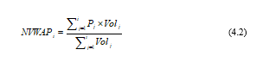

Market impact is the premium a trader pays to execute more than is offered at the best price. It is defined as:

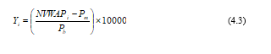

Up to the -th order on the side of the market that the trader wishes to fill, the cumulative volume is normalized as follows:

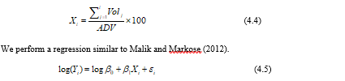

Where β1 is the slope of the NVWAP curve, capturing the effects of curve steepness and flatness. The available trading volume in a downtrend , uptrend . The increased cost (profit) of buying (selling) in a rising (declining) market is reflected by the change in the slope of the curve (Pratapa Raju and Jaya Laxmi, 2022).

Calculating the variation of the total volume available on both sides of the limit order book for a given period allows the determination of contraction and expansion curves. Trending upward ; downward trend . Investors on the other side will strive to consume liquidity rapidly as the price starts to climb in order to benefit from potential greater returns. More people will enter this competition on the demand side. The volume on the supply side will also decrease at the same time.

Suppose normalized volume and market effect are two random variables with a common probability density function for nonparametric kernel regression. The expectation given the condition is described as:



Where  the conditional probability density of given  and  its marginal pdf of Equation (4.6)'s estimation is based on the Nadaraya-Watson estimator, which was developed by Nadaraya and Watson in 1964.

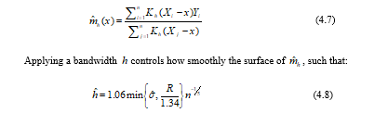

Where  according to Hardle et al. (2004), quoted by Malik and Ng (2012) as the interquartile range. The following correlation between market impact and a vector of exogenous factors is provided by the multivariate Nadaraya-Watson estimator:



with the multivariate kernel function 

Following the imposition of monotonicity and a few algebraic twists, the seasonal component of the market impact based on normalized volume can be calculated by:

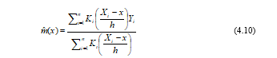

Let then represent the market impact of a normalized volume at a particular time of day, the seasonal component of the market impact dependent on normalized volume at time-of-day can be calculated using the Nadaraya-Watson estimator.

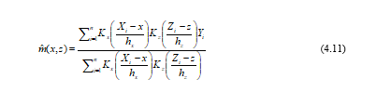

When there are two kernels,  and , which permit  and  to diverge (and depend on the variance of  and  ). In this instance, the observation's weight (, ) is proportional to:



The multivariate Nadaraya-Watson estimator, which is derived from Equation (), is then used to calculate the effect of time of day (TDV) on NVWAP. 4.11) (for a specific amount of time and order size).

# Section 5: Time Stamps Demand and Supply Curves for Price Trend Prediction

Continuous trading and call auctions differ in that in the former all trades are filled at the same price and calls are placed at different prices as orders move up or down the book and the book moves. In the previous sections, we discussed the distinction between equilibrium outcomes resulting from uniform prices (Kyle, 1985, 1989) and outcomes resulting from discriminatory prices. These analyses indicate that the uniform price auction has a slight spread of trade, whereas the discriminatory price auction does not. For large deals, the discriminatory price auction, on the other hand, has lower transaction costs.

This is in line with the empirical findings of Kehr, Krahnen, and Theissen (2002), who discovered that for smaller trades, the Frankfurt Stock Exchange call market has lower transaction costs than the futures market. In addition to indicating that strategic behavior is prevalent in financial markets, the findings presented in the preceding section also suggest that increasing the number of market participants mitigates its negative effects. Which trading strategy makes this efficiency converter easiest to use? This question is addressed in Williams, Satterthwaite, and Rustichini's (1994) responses. Consider strategic agents who act to share the risk (and don't make negative decisions about shared costs and order fulfillment costs) to bring their analysis to our framework.

Half of the agents own shares and may want to sell them. The other half don't have stocks but may want to buy some. Agents not only have different purposes, but also different risk transfer ratios, resulting in different equity valuations. The seller's stock valuation (his security equivalent) in our normally distributed, simple exponential argument framework is: 14i34 2, and if he sells at price p, his trading profit is: P ¡(¼ ¡I ¾ 2) . If buyer J buys a stock at a price, his profit is 29% by trading as follows: Socially optimal trading gives the stock to the agents with the highest ratings.

But strategic behavior can lead to inefficiencies that prevent mutual exchange. According to Rustichini, Satterthwaite, and Williams (1994), a double auction, also called a call market, is an auction that allows buyers to bid on a share while sellers can limit bids on a share to be sold. They show that the equilibrium changes from N towards efficiency as maturity is reached. o is the maximum possible inefficiency (1 N2). According to Satterthwaite and Williams (2002), no other trading mechanism is evolving faster towards efficiency. In this sense, the call auction is the best way to structure the market (Leddy *et al.*, 2018).

This section looks at the statistical characteristics of the highest bids, asks for HSBC stock data every five minutes for three months (June to August 2007), looks at average daily volumes (ADV), and talks about how ADV changed before and after the financial crisis.

Figure:1.1



From June to August 2007, FIGURE 1.1 shows how the mid-price and price return changed over time. Bull market periods are followed by market downturn periods, which define the price dynamics (bear market). The negative association between boom markets and stock return volatility is also depicted in the figure. Volatility is low during a boom but it is high during a bear market when stock values are decreasing, which is a demonstration of the so-called volatility paradox.



The price return sample statistics (Figure 1.1) indicates that the skewness of HSBC stock returns is positive in the following month of June and July 2007 and shows a negative skewness in August. This illustrates that while large positive returns were more often in the month of June and July and negative returns in the month of August. The price return data are leptokurtosis, which means they do not follow a normal distribution, as evidenced by the kurtosis being significantly over 3 throughout the course of the three months.

## Demand and Supply Curves

FIGURE x depicts both peaks and troughs in the intraday cumulative price return on the 11th, 12th, and 13th trading days of July 2007. The sequence of peaks and troughs defines each interval across which we calculate and evaluate changes in the NVWAP curves. Consequently, a peak or trough serves as both the beginning of the subsequent downtrend interval and the conclusion of consecutive uptrend intervals.

Figure 1.2

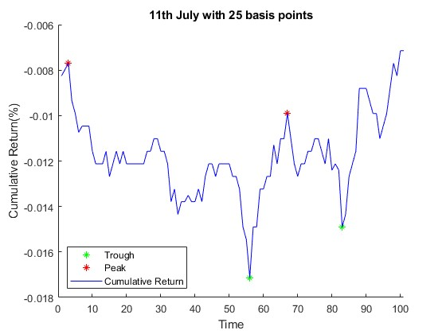

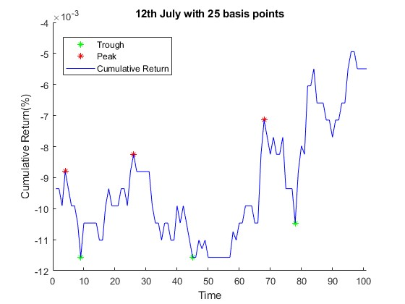

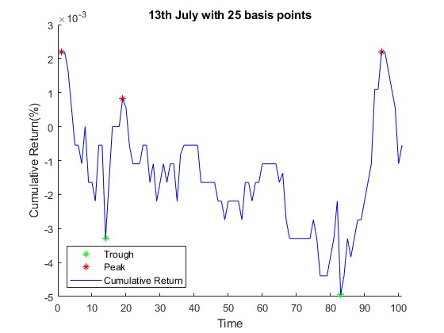

After the intervals have been established, the HSBC stock's NVWAP curves at the start and end points of the downtrend and the uptrend above the cumulative price return as of July 11 are depicted in Figure 1.2. The beginning and end timestamps of the downward trend between 08:15 (peak) and 12:40 PM (trough) are depicted in the top panel.

During this time, the bid side NVWAP curve gradually narrows and steepens, while the ask side NVWAP curve gradually broadens and flattens. From 12:40 (trough) to 13:45 (peak), a period of upward trend is depicted in the middle panel. The ask side NVWAP curve is now gradually narrowing and becoming steeper, while the bid side NVWAP curve is now gradually widening and becoming flatter, in contrast to the interval before it.

**Figure 1.3 (Downward Trends for 11th July)**

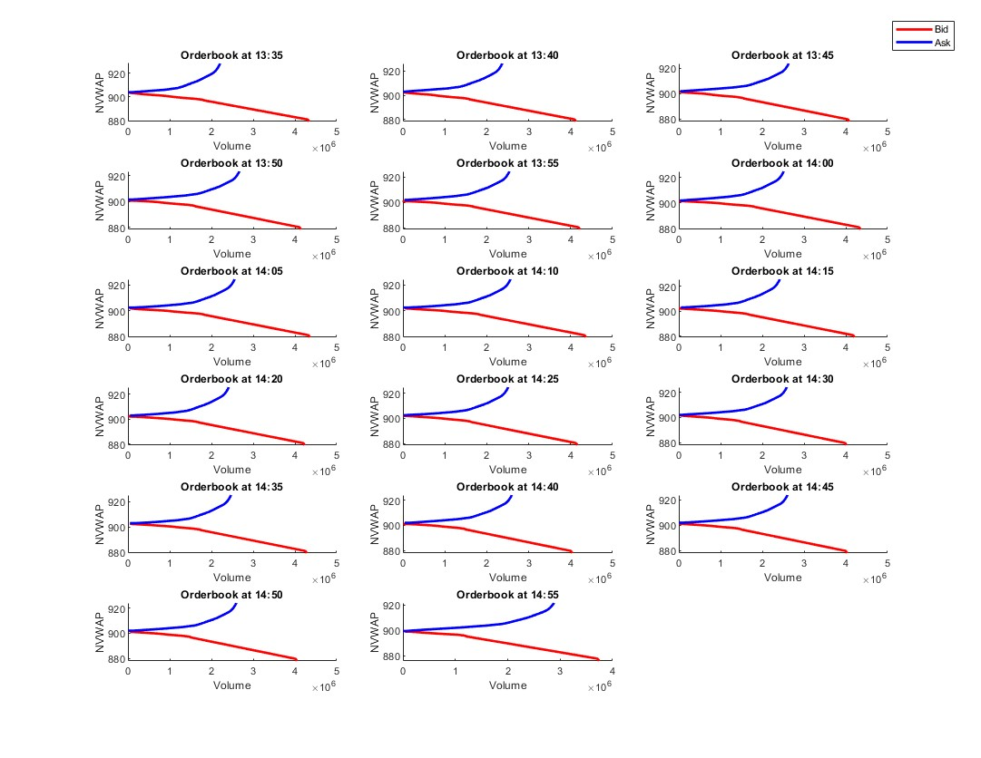

**Figure 1.3 (Upwards Trends for 11th July)**

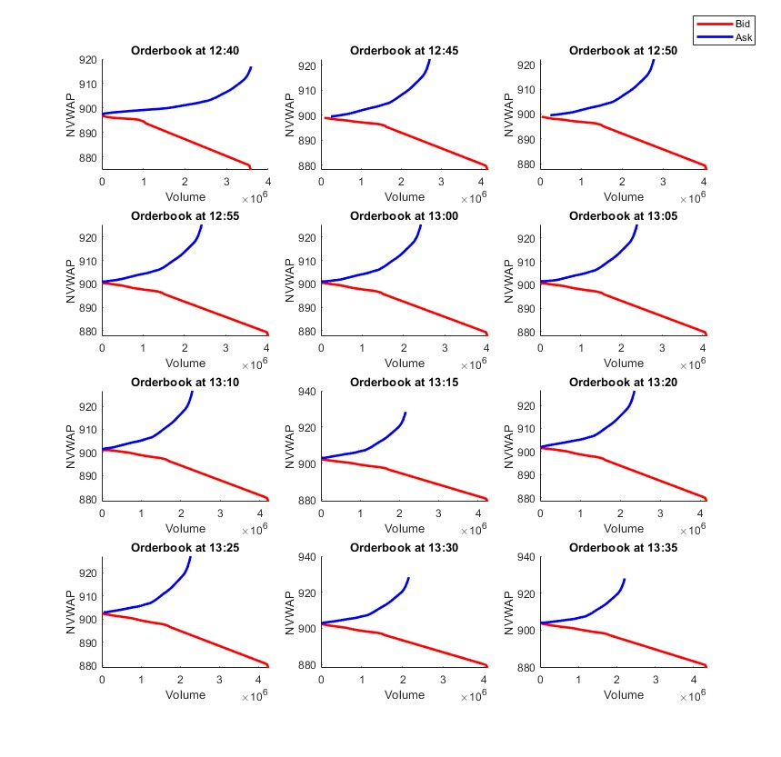

Figures 1.3 and 1.4 depict the HSBC stock's NVWAP curves at the beginning and end of the uptrend and downtrend, respectively, above the cumulative price return on July 12, 2007 and July 13, 2007. The forms of the demand and supply curves for liquidity support the claim made by Malik and Markose (2012) that "When the market price rises (uptrend), the volume of the ask side (liquidity supply) gradually falls." This is similar to the examination of the NVWAP curves from July 11th.

This effect causes the shape of the NVWAP curve on the ask side to gradually shrink and become steeper. On the bid side, the NVWAP curve develops in the opposite direction; It flattens and broadens over time. A similar pattern (downtrend) emerges when market prices fall. The bid side NVWAP curve gradually contracts and becomes steeper while the ask side NVWAP curve gradually expands and becomes flatter in a downtrend.

**Figure 1.4 (Downward Trends for 12th July)**

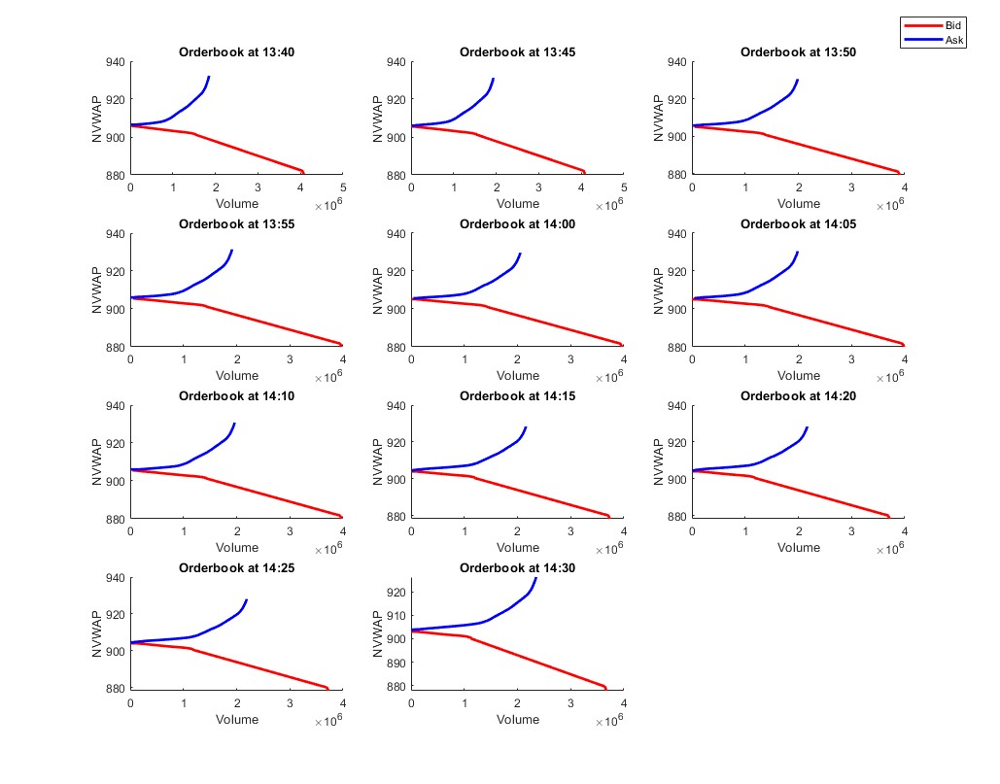

**Figure 1.4 (Upwards Trends for 12th July)**

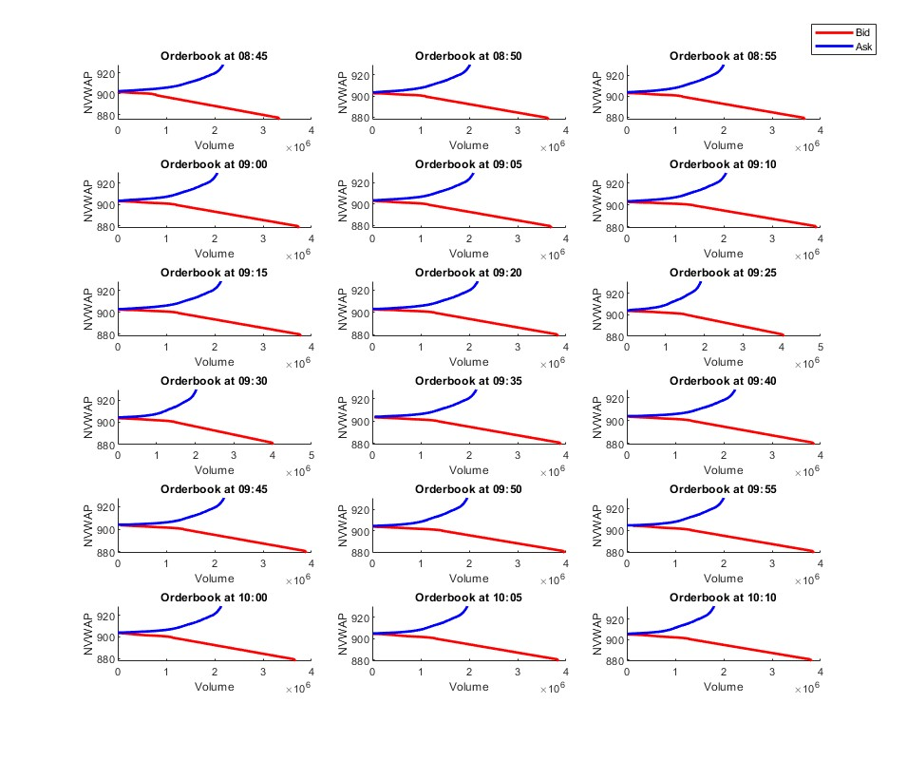

**Figure 1.5 (Downward Trends for 13th July)**

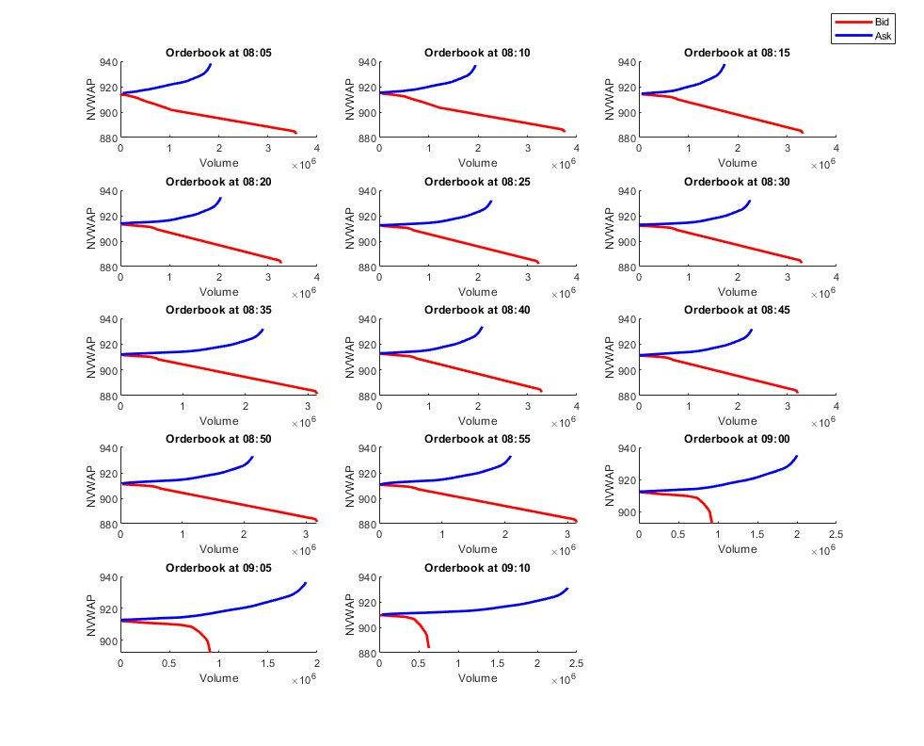

**Figure 1.5 (Upwards Trends for 13th July)**

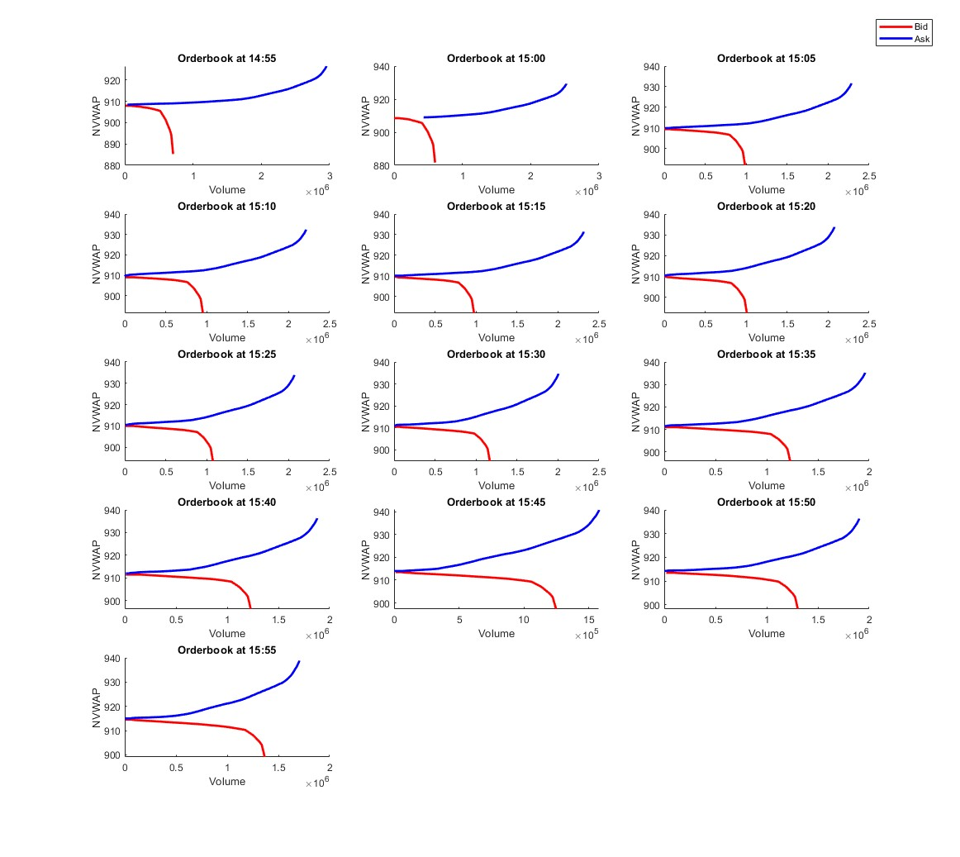

For the three days that were previously examined, TABLE 4 displays the NVWAP curve dynamics. The data for July 11th reveals that the BetaBid values are 0.3368 and 0.2812 at the beginning and conclusion of the first uptrend interval (between 12:40 and 13:45, respectively). Matching the Quantbid numbers 3,575,852 and 4,339,285. The log (BetaBid)and log(Quantbid) are, respectively, -0.1805 and 0.1935. A decrease in the BetaBid signifies that the NVWAP-Bid curve is flattening, while an increase (positive change) in the Quantbid in the suggests that the curve is growing, according to Malik and Markose (2012). The results on the BetaAsk indicate that the values at the beginning and end of the first uptrend interval are 0.8325 and 0.336, respectively, while the values for the QuantAsk are 1,764,615 and 3,589,093 respectively. Δlog(BetaAsk) and Δlog(QuantAsk) corresponding logs are 0.90 and -0.84 respectively. The NVWAP-Ask curve has been suggested to be contracting by the negative log(QuantAsk) and steepening by the positive log(BetaAsk), respectively.

According to TABLE 5, the Beta-bid value for the beginning and end of the first downtrend interval was 0.3714 and 0.3368, respectively, and the corresponding Quantbid was 3,743,962 and 3,078,478. The logs for BetaBid and Quantbid are respectively -0.0975 and -0.0459. The curve appears to be contracting if the value is negative. At the beginning and end of the first downtrend interval on the ask side, BetaBid values are 0.8325 and 0.336, respectively, with QuantAsk values of 1,764,615 and 3,589,093. The changes in and are 0.71 and -0.9073 respectively. While an increase in QuantAsk shows that the NVWAP-Ask curve is widening, the negative fall in BetaBid reflects the curve's flattening.

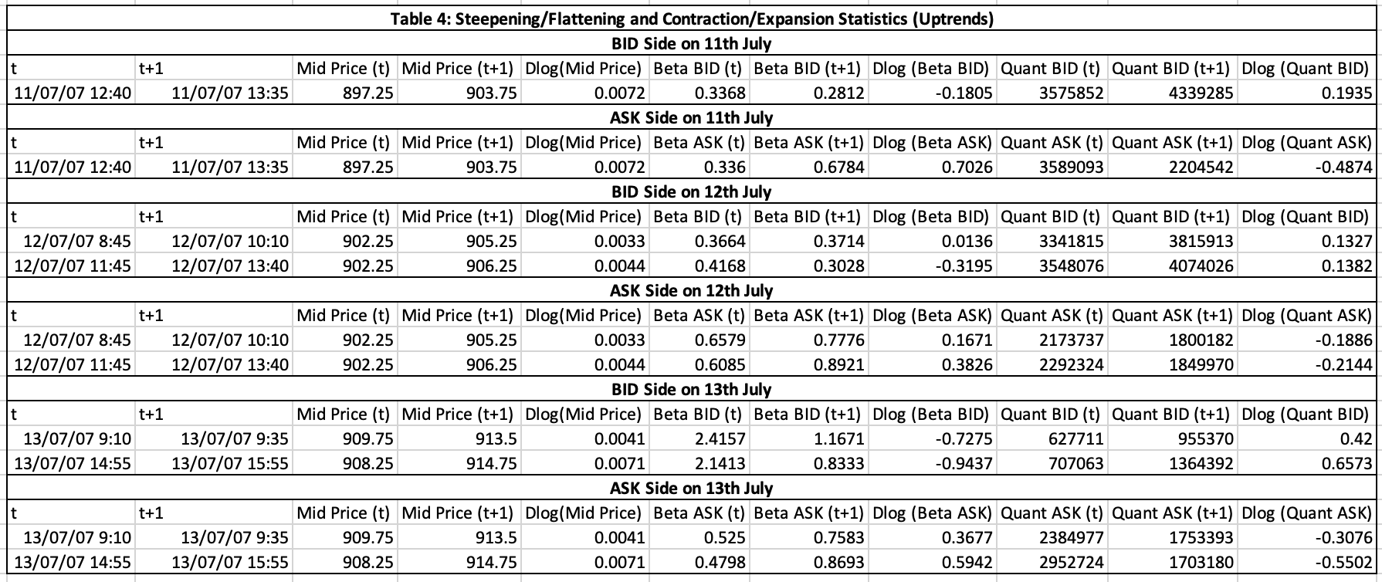

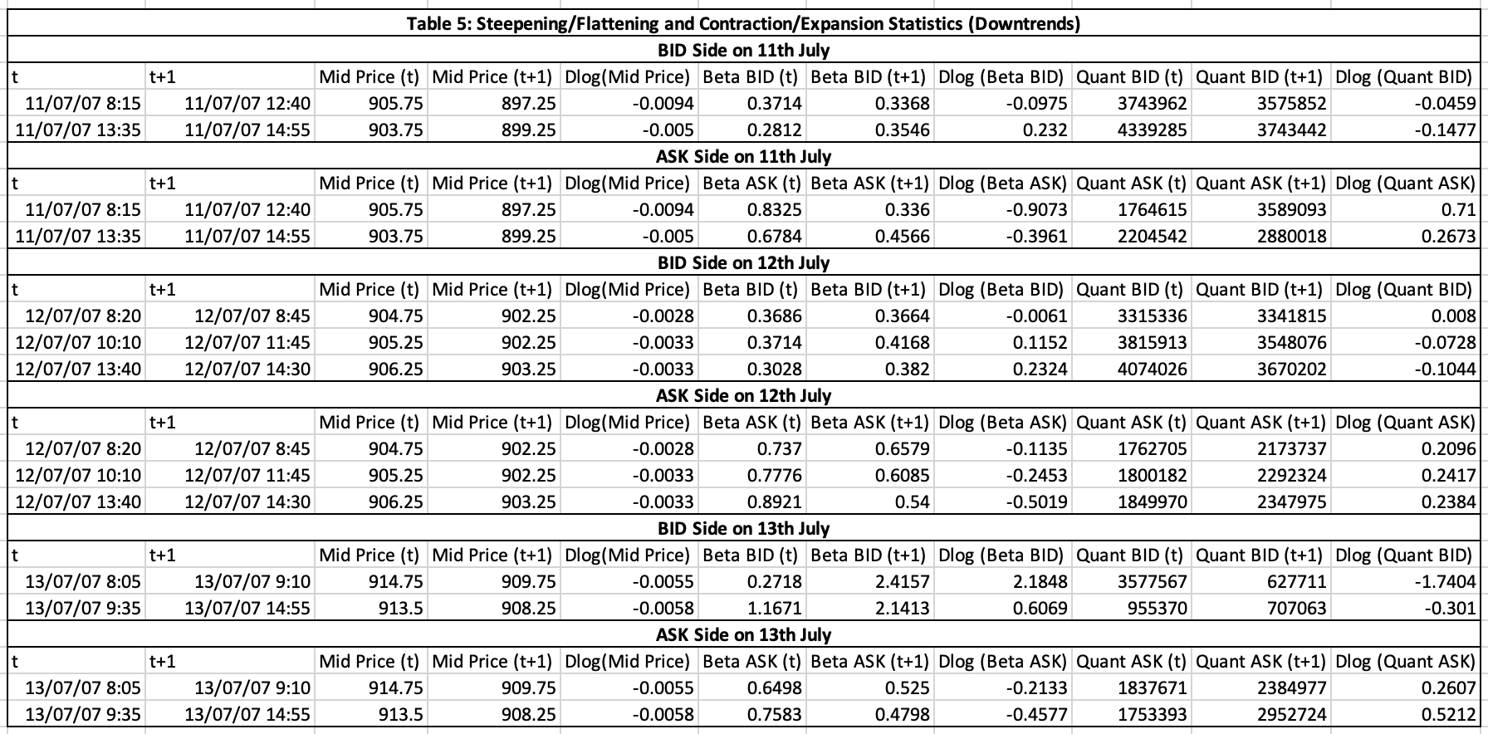

The findings from the designated intervals over the entire three-month period are shown in Table 6 below. Taking into account the steepening/flattening (S/F) behaviour of NVWAP curves as the sum of observations where the trend is up Δlog(BetaBid)<Δlog(BetaAsk)) and down Δlog(BetaAsk)<Δlog(BetaBid). Contraction and Expansion (C/E) behaviour of NVWAP curves as the total number of observations where in an uptrend Δlog(QuantBid)> Δlog(QuantAsk) and in a downtrend Δlog(QuantAsk)> Δlog(QuantBid) and Total as the total number of observations where price return exceeds the 25 basis points threshold. Overall, the detailed results are in line with the explanation of the four statistics' performance for the uptrend and downtrend intervals used as examples above. In 98.61% and 98.33% of the total data, respectively, steepening/flattening and contraction/expansion of NVWAP curves behavior recognized the price trend as expected. These findings are in line with those of Malik and Markose (2012), and as acknowledged by these authors, they support the validity and effectiveness of the suggested NVWAP approach.

* **Table 6**

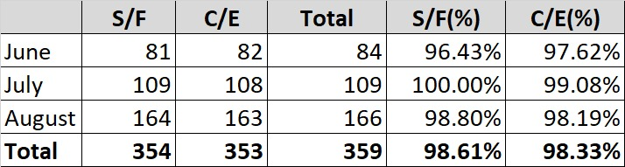

**Market Impact Analysis.**













Agents such as dealers, brokers, dealers and limit order specialists can provide liquidity. These parties may have different preferential rules, different degrees of market power, and different amounts of information. For example, until recently, specialists had access to instant electronic insight into Sneezes' limit book, and traders only had the ability to halt issuance on the NASDAQ and London stock exchanges until 1997. The differences between the liquidity providers are small. Important in pure frontier markets like the Paris Stock Exchange. Defining the different rules regarding liquidity providers and the information they have access to is a key issue in the design of trading systems.

The case of the Sneeze specialization illustrates some undesirable selection problems due to imbalances in the timing of trading options offered by different liquidity providers. The specialist can place the sellable order against the other limits or even place the entire order when it comes to the floor. He can achieve this by booking or "stop market orders" and ensuring the execution of the offer afterwards or price improvements. According to Soaanos (1995), specialist dealers are often listed in the product range, such as price increases. Since the decimation, the spread between liquid stocks has often been in the cent range, limiting the potential for price improvement.

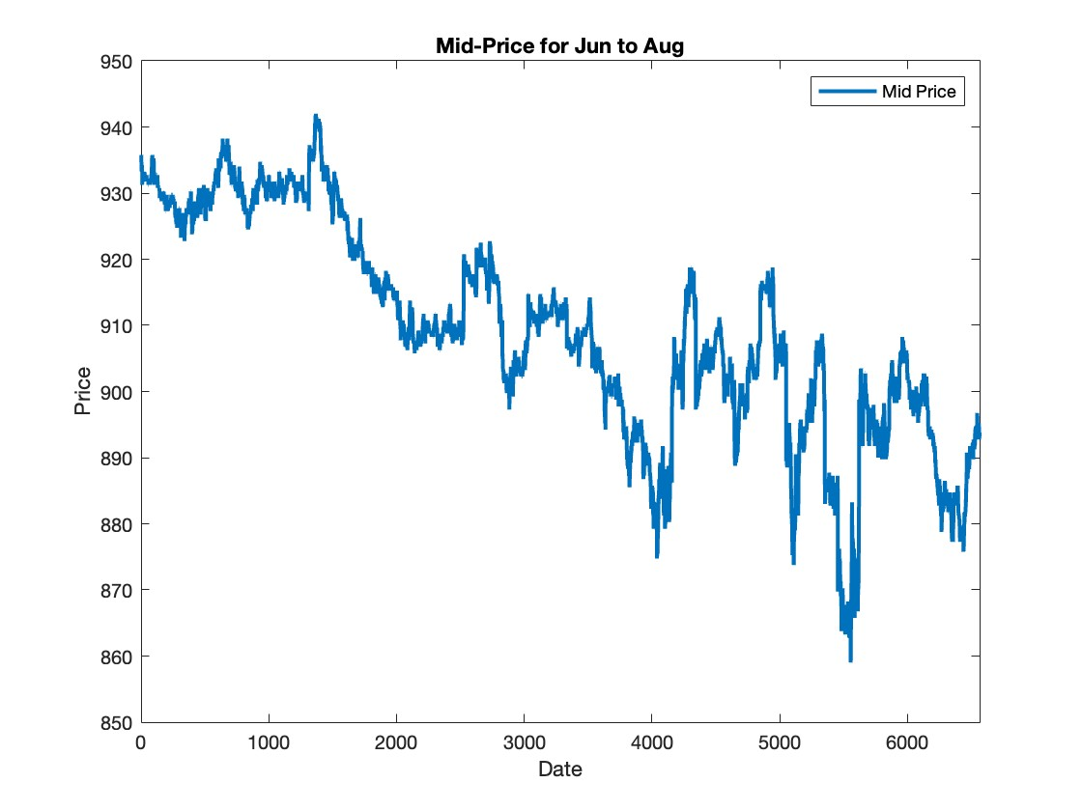

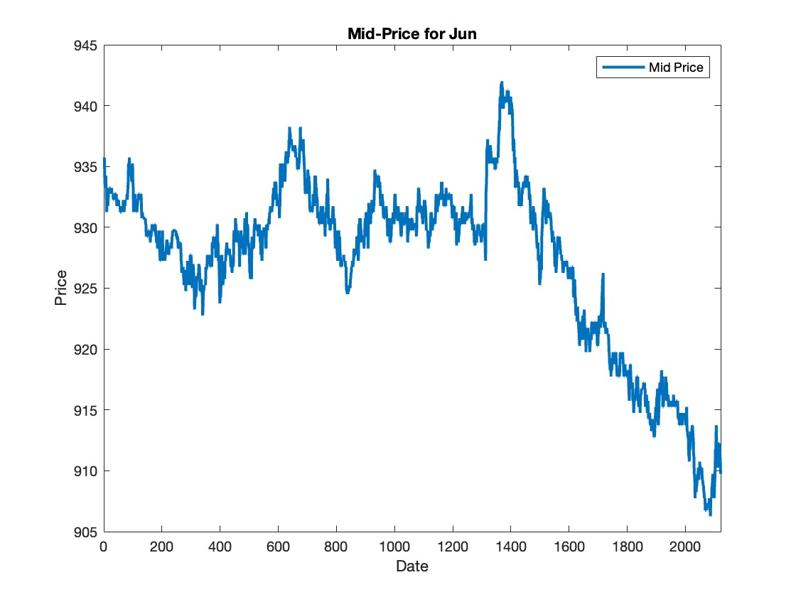

5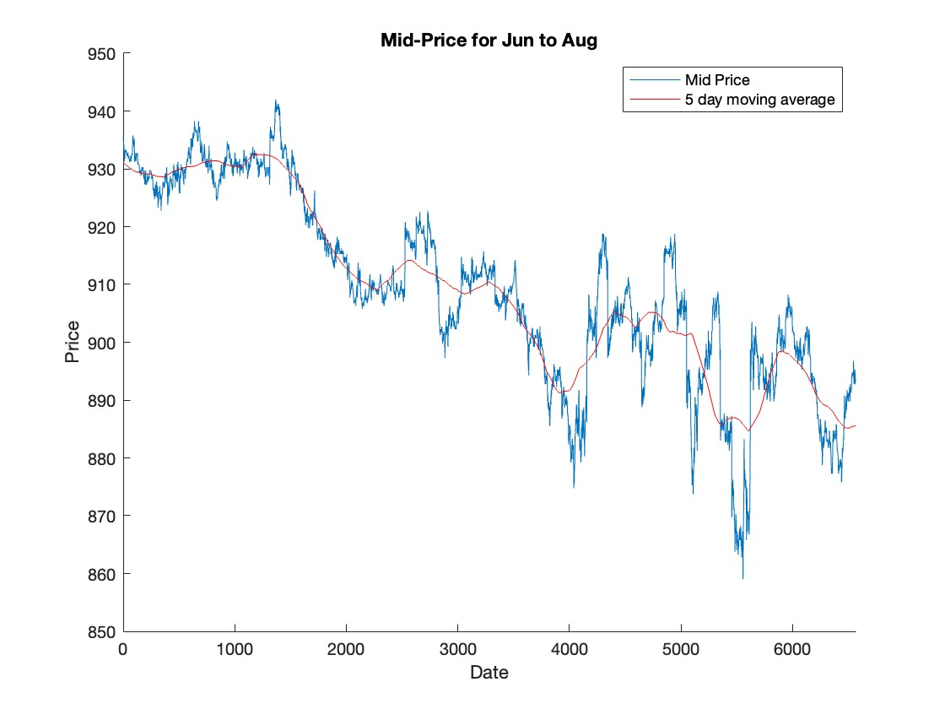

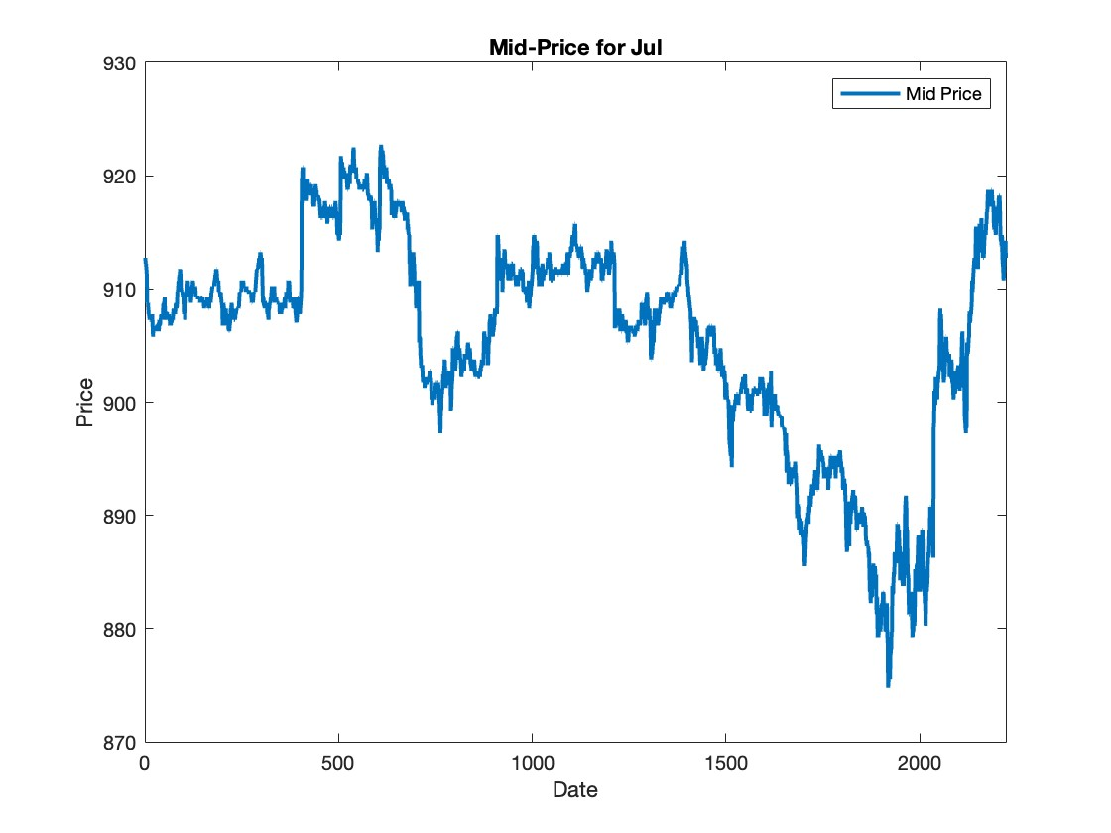

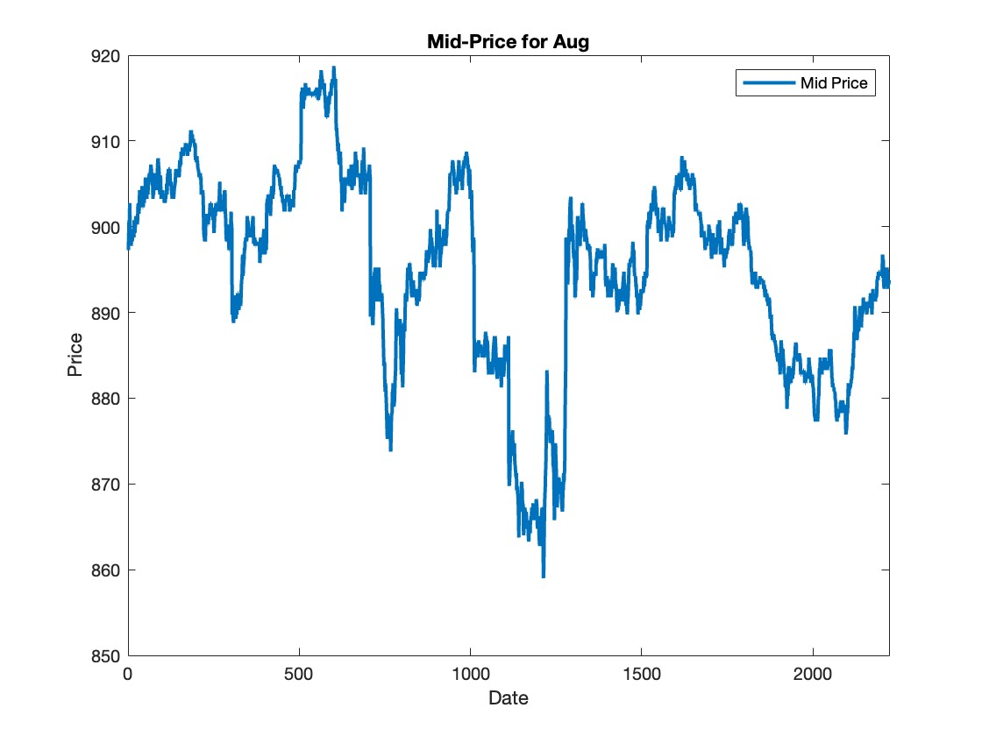

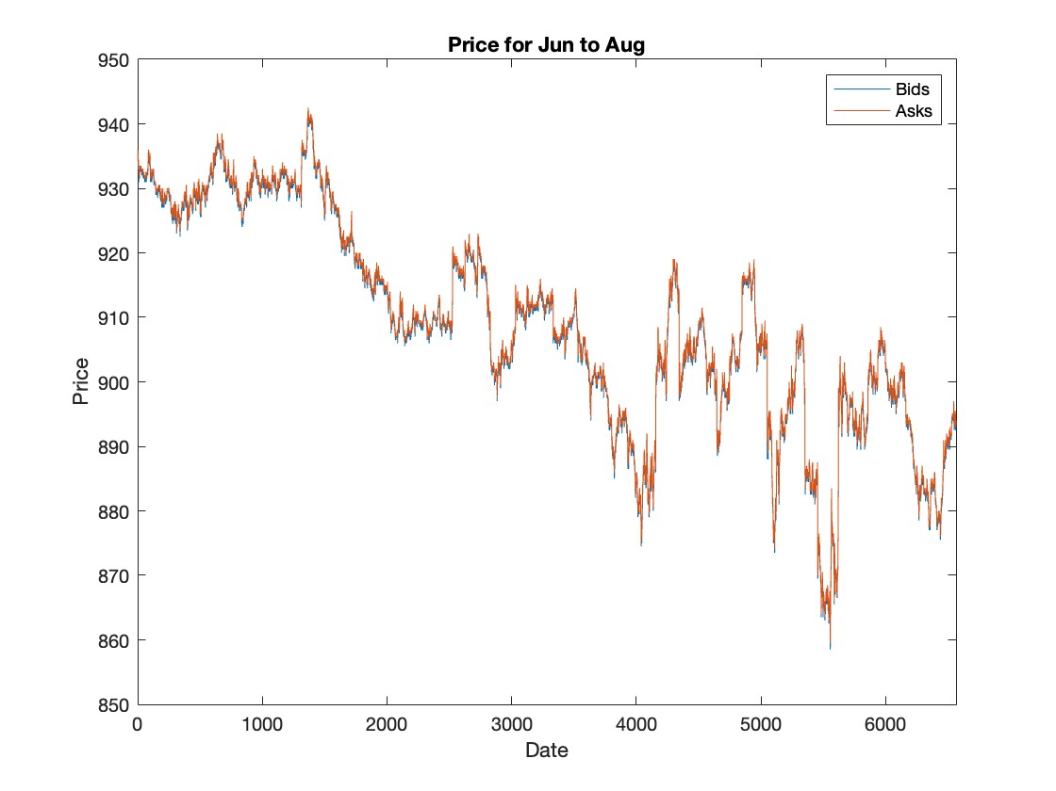

# Section 6: Price Impact Methodology

While the above arguments suggest that fragmentation reduces market quality when liquidity providers compete in the core market, this is not always the case when liquidity providers have market power. This allows the primary market to benefit from the competitive pressure of the secondary market. In fact, some empirical studies point in this direction. Similarly, the findings of Lightfoot, Martin, Peterson, and Sirri (1999) do not lend credence to the hypothesis that foreclosures reduce the quality of financial markets. Battalio, Greene, and Jennings (1997) examined the effects of a reform that allowed brokers to execute client orders independently without respecting the time priority of other traders at the Boston and Cincinnati Stock Exchanges. Stock options face little competition, as stated by Neal (1987), Mayhew (2002), De Fontnouvelle, Fishe, & Harris (2003), and others (Stetter *et al.*, 2018).

They found that brokers were selected from their specialty divisions largely to sniff out and develop these regional markets. This caused the sneeze belt to fall off. Similarly, according to Battalio (1997), Madoff Securities began buying ° commands to distract the ° Ow command from sneezing, causing sneeze intervals to collapse. According to Biais, Bisierre and Spatt (2002), competition between two separate markets - Iceland and NASDAQ - can be a useful adjunct to competition in each market.

Glosten (1998) says that although there are fewer incentives to provide liquidity in the primary market because of fragmentation, this does not necessarily mean that overall depth is reduced. Take a look at Pure Pure Limited's I and II books. Within their own quotes, time priority is respected by both books, but not between markets. Market order users place their orders at random and send them to one of the exchanges. However, according to order processing rules, the remainder of an order must be sent to the opposite exchange for execution when one exchange's volume is exhausted. Let 1 represent the likelihood of a market order being booked on the exchange.

As a result, E [v JQ > Qi] should have a higher bid price than E [V JQ > Qii + Qi]. As a result, listing the amount on each exchange is less appealing. But if there are two exchanges, the total amount of Qi + Qii will be larger. As competition in the stock market forces things to compete with average stocks rather than marginal stocks, the likelihood of in framarginal stocks goes down. The size of this effect decreases as the tick size decreases and the limit disappears.

Even though the above-mentioned results lead to a somewhat hazy conclusion, they may indicate some unusual aspects of architecture in American markets that are not found in other settings. First, if time priority were given to all markets, the aforementioned negative effects of market competition would not occur.

Second, the likelihood of orders being pulled from streams can lead to tenant rejection given the costs incurred by other actors in the relevant transactions. This implies that market competition would not be detrimental if time priority applied between markets and ii) no one received privileged status. Please note that in the event of a competition between limited electronic deer books, terms a) and ii) will still apply, with priority prices and times for each market.

"The inevitability of limit order e-books" by Glosten (1994) demonstrates the consolidation of all potential sources of liquidity in this setting. The coexistence of markets can also be advantageous in gaining the stock market's competitive advantages due to the dynamics of the market structure and the incentives to innovate in the development of new trading mechanisms and technologies. For example, from the mid-1980s, competitive pressures from London drove the modernization of European stock markets, including the move to electronic markets and continuous trading. However, Foucault and Parlor show that competition on the stock exchange does not necessarily lead to optimal market structures. In their model, exchanges choose listing fees and trading costs based on how attractive they are to investors and companies interested in listing.

It may be optimal to design two competing exchanges with separate fee and cost structures to serve two different market niches because companies differ in how much they value trading cost reductions and because different combinations of fees and costs are viewed as differentiated products. In contrast to a monopoly situation, the corresponding duopolistic equilibrium can lead to reduced welfare rather than maximization (Yu, Lin and He, 2005).

Using normalized order sizes up to 5% ADV on the x-axis and time of day on the y-axis for 5-day rolling windows, heat map show 3-dimensional patterns of the bid and ask side TDV market influence for HSBC stock. With a maximum market impact value of 200 bps, symbolized by the darkest red color, the graphs' market influence is indicated by the color of the contours as displayed in the scale on the color bars that follow each graph.

The bid side TDV market impact intraday pattern appears to be consistent for all five days of the July 2007 rolling window, amounting to about 100 bps, with an intraday peak forming at the start of the trading sections, between. The ask side, however, exhibits an overall impact that is significantly greater than the bid side, amounting to more than 120 bps. Moreover, the bid side TDV market impact looks to be between 110 and 120 bps, with an intraday high occurring at the commencement of the trading sections, between. However, the ask side demonstrates an overall impact of more than 200 bps, which is much higher than the bid side.

The ask side typically has an impact of nearly 200 bps, which complicates stock pricing. On the other hand, the bid side can occasionally be seen to be a bit aggressive, which has the opposite effect on stock price. The dispersion can be seen between 3 months in the intraday. This can be seen notably in August; it can be viewed as an exception because it occurs throughout rising intervals.

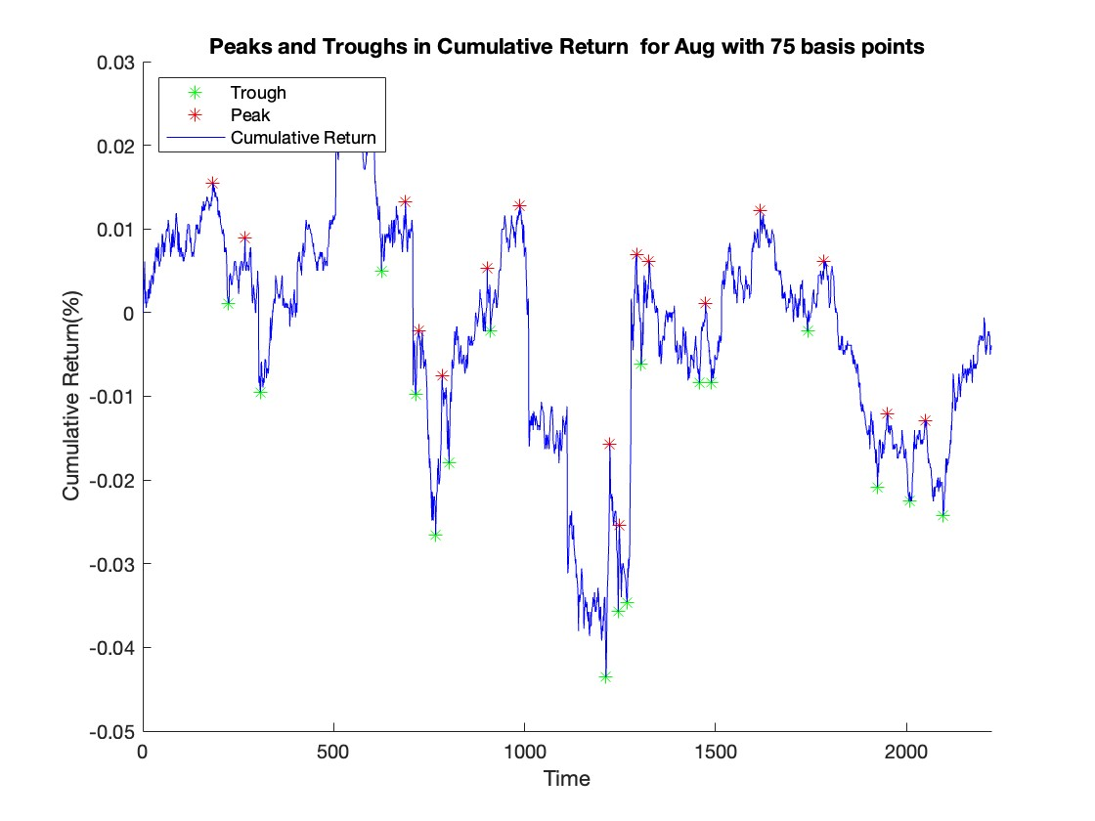

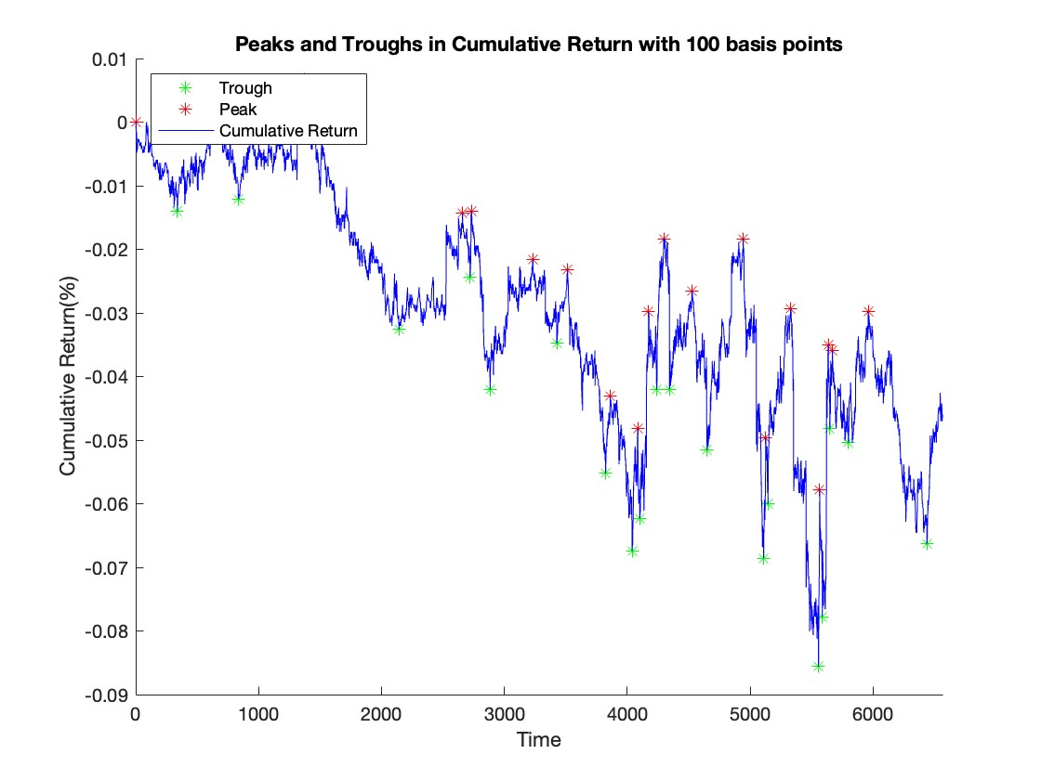

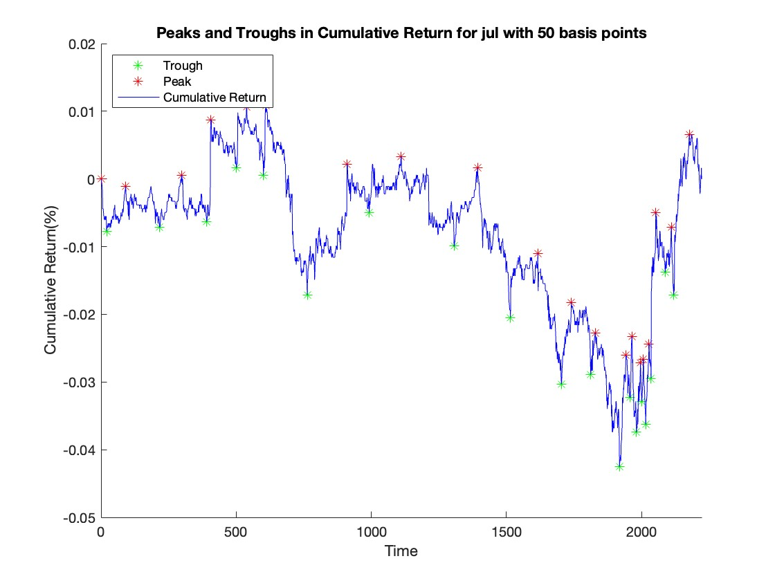

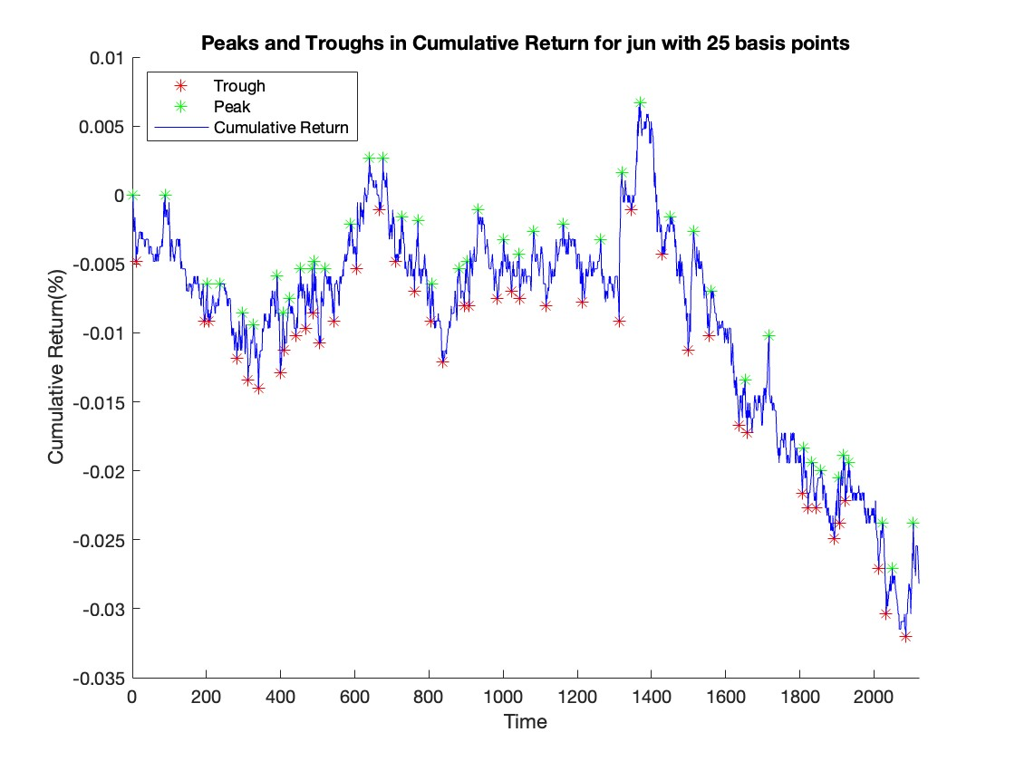

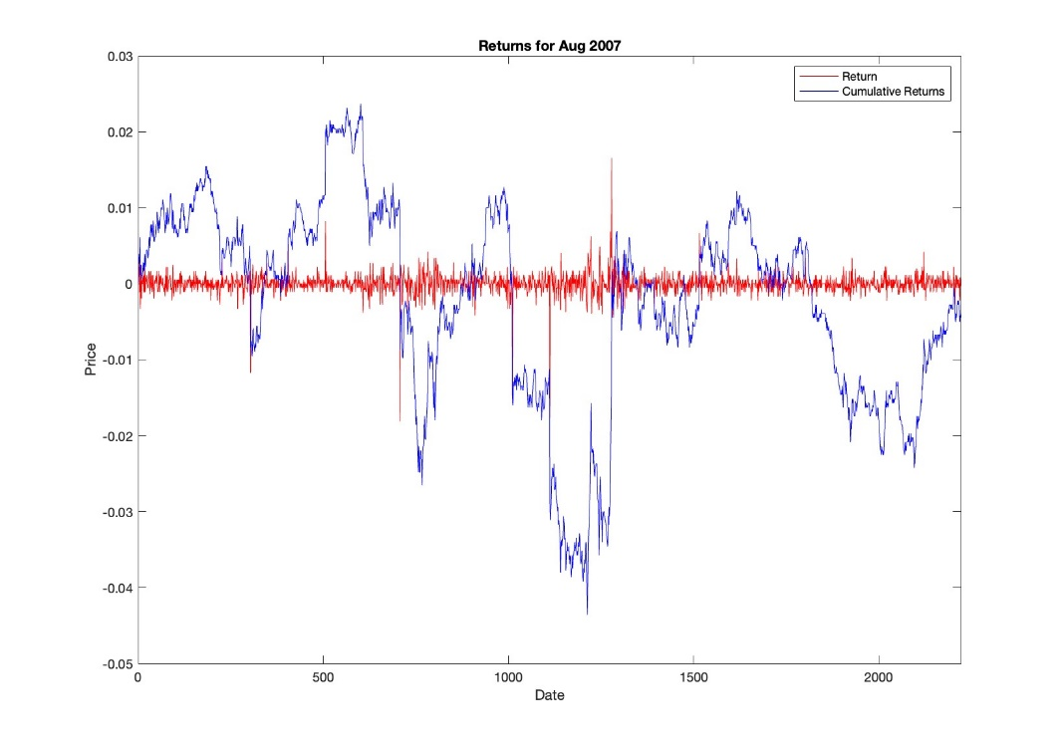

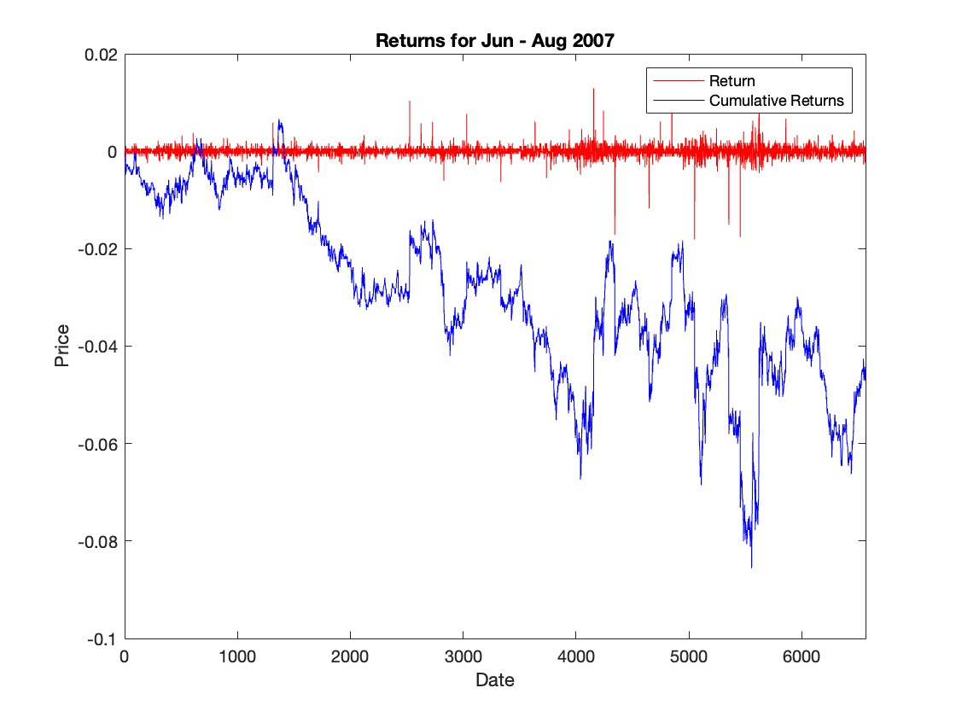

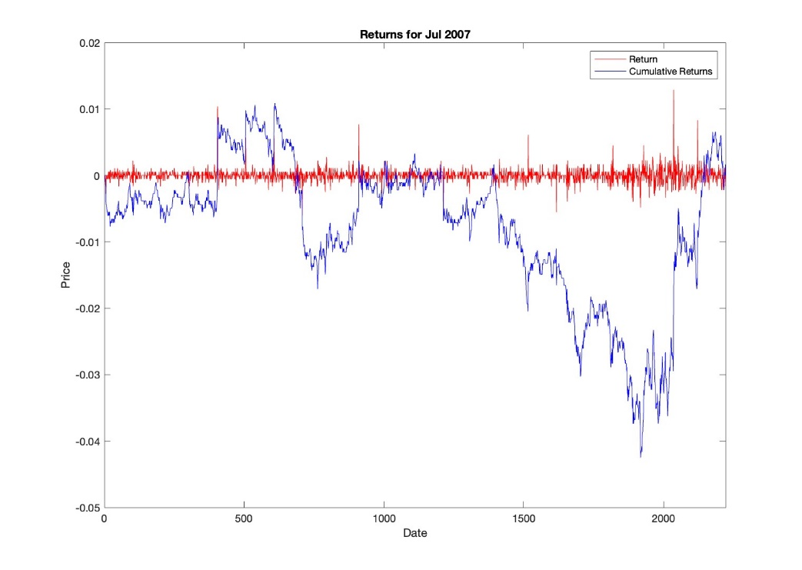

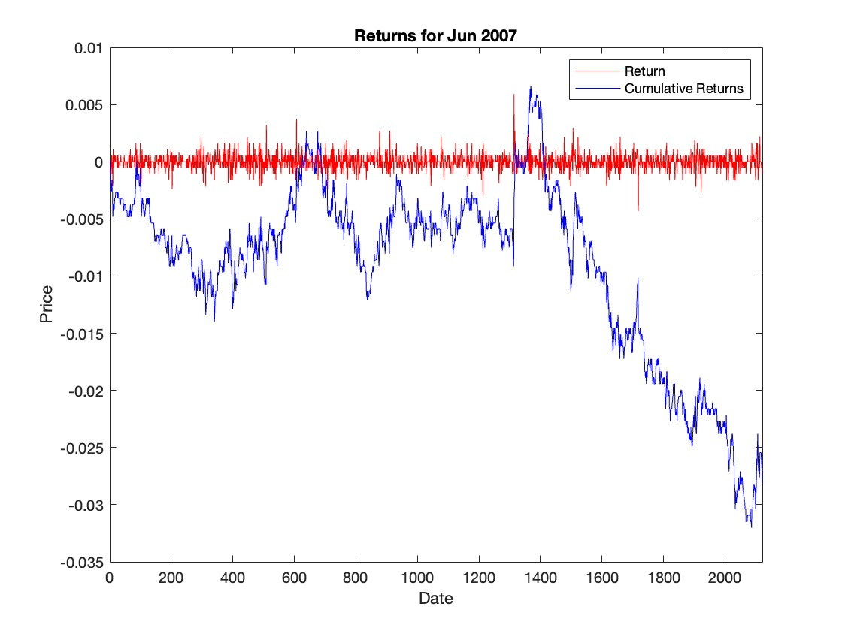

# Section 7 Conclusions

This study has led some to conclude that the microstructure of the market is very important. According to the data collected in Sections 1 and 2, trades affect prices and do not always result in fully efficient allocations due to order processing and inventory costs, adverse selection and market power. The research in Part 3 shows that market organization can accentuate or mitigate these costs and inefficiencies.

Pricing grids should not be too rigid to reduce market power and facilitate risk sharing. In addition, free access to the liquidity of the offer should be made possible. Markets should be open and allow different liquidity providers to provide a level playing field in terms of market information, priorities and order processing procedures to reduce selection costs. Limit order e-books are clearly an obvious means of implementing these desirable features of the market microstructure: they allow countless investors around the world to monitor market information and compete for liquidity; They allow the implementation of explicit algorithms such as continuous double auctions and call auctions and apply predefined priority rules (FEMP *et al.*, 2019).

In fact, in recent years developed nations (Euronext, Xetra, SETS, Iceland) and developing countries (China, Africa, Brazil) have moved towards electronic orders with open borders. The electronic limit order book, which allows orders to be executed automatically, is becoming increasingly important for the NYSE. In line with our belief that the open electronic order book will always exist, we expect this market model to evolve. It's likely that there will be more limit orders side by side than one huge overall order book. This type of coexistence is desirable as competition between markets as well as competition between liquidity providers within a single market is important to reduce market power and interference.

# References

Agirdas, C. (2015) ‘How did medicaid expansions affect labor supply and welfare enrollment? Evidence from the early 2000s’, *Health Economics Review*, 6(1). Available at: https://doi.org/10.1186/s13561-016-0089-3.

FEMP *et al.* (2019) ‘Support for Setting up an Observatory of the Building Stock and Related Policies.’, *Applied Energy*, 11(3), pp. 317–326.

Leddy, M.B. *et al.* (2018) ‘High-Throughput DNA Sequencing To Profile Microbial Water Quality Of Potable Reuse High-Throughput DNA Sequencing To Prole Microbial Water Quality Of Potable Reuse’, *Water Innovation*, (January), pp. 33–37.

Pratapa Raju, M. and Jaya Laxmi, A. (2022) ‘Implementation of Load Demand Prediction Model for a Domestic Load Center Using Different Machine Learning Algorithms—A Comparison’, in *Lecture Notes in Networks and Systems*, pp. 445–467. Available at: https://doi.org/10.1007/978-981-16-5640-8_35.

Sarkar, S., Tiwari, S. and Giri, B.C. (2022) ‘Impact of uncertain demand and lead-time reduction on two-echelon supply chain’, *Annals of Operations Research*, 315(2), pp. 2027–2055. Available at: https://doi.org/10.1007/s10479-021-04105-0.

Segletes, S.B., Grote, R. and Polesne, J. (2000) ‘Improving the Rod-Penetration Algorithm for Tomorrow ’ s Armors’, *Science*, (December), pp. 66–71.

Stetter, J.R. *et al.* (2018) ‘Wireless Zero-Power Air Quality Electrochemical Sensor Card for Iot Applications’, *ECS Meeting Abstracts*, MA2018-01(42), pp. 2418–2418. Available at: https://doi.org/10.1149/ma2018-01/42/2418.

Yu, Y., Lin, W.M. and He, J. (2005) ‘Design and application of power digital certificate service system’, *Dianli Xitong Zidonghua/Automation of Electric Power Systems*, 29(10), pp. 64–68.

Zhang, Y., Li, B. and Krishnan, R. (2020) ‘Learning individual behavior using sensor data: The case of global positioning system traces and taxi drivers’, *Information Systems Research*, 31(4), pp. 1301–1321. Available at: https://doi.org/10.1287/isre.2020.0946.

Zook, M. and Grote, M.H. (2022) ‘Betting on Brexit: The Financialization of Frontier Data’, *SSRN Electronic Journal* [Preprint]. Available at: https://doi.org/10.2139/ssrn.4023257.

# Appendix

